**Assignment – 1**

Problem Statement:

Description:

1. Create a database with “car_db” name.

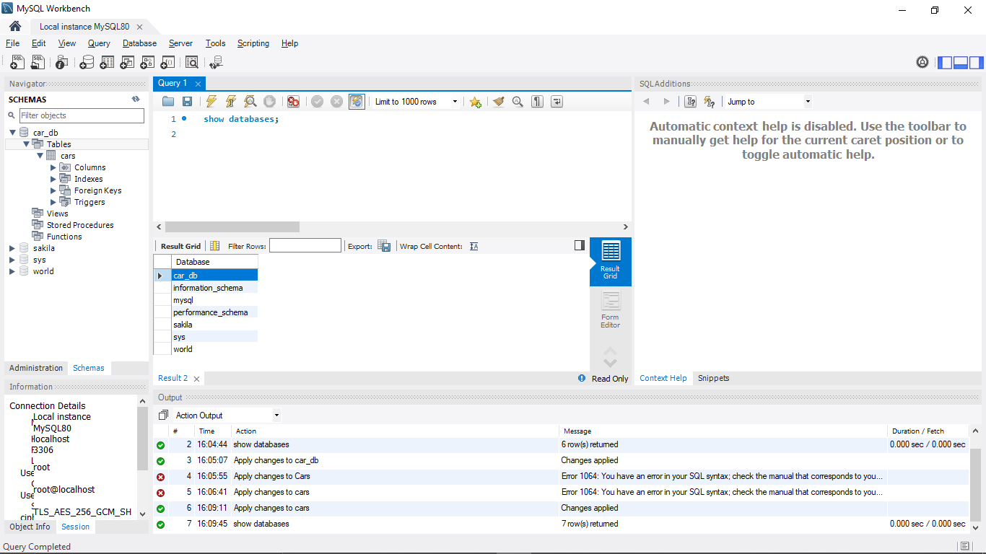

2. Create a table called Cars with the following fields:

S_no varchar (6)

Name varchar (15)

Model varchar (15)

Year varchar (15)

Price varchar (20).

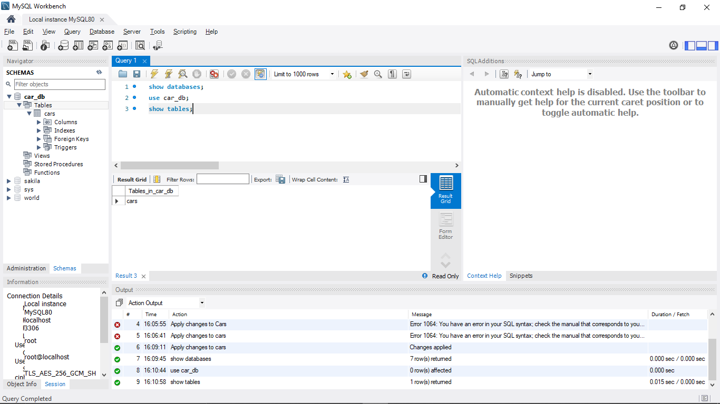

1. Insert the 5 records to the car table and assign primary key for the table.

Done

1. Display the all the records from the car table.
2. 